Similarity
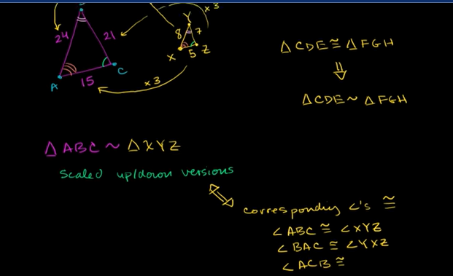
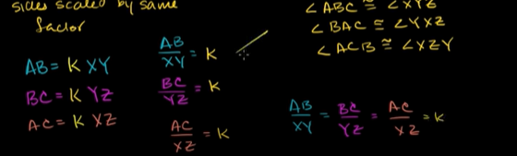
Similarity Criteria/postulates:
AA, SSS , SAS ,
Similarity:
1) Ratio of the corresponding sides of a triangle are same.
2) All angles are same, but even if 2 angles are same its similar.

Congruence:
Criteria/postulate:
SSS, SAS, ASA, AAS
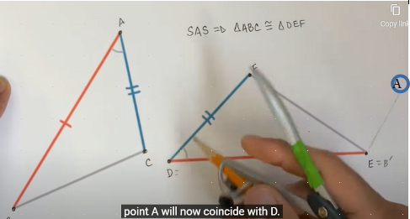

Then we perform a rotation to move A to D or D=A’
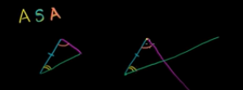



Congruence> theorem concerning quadilateral properties
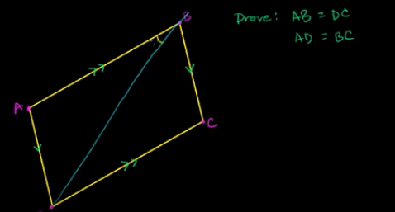

Parallelogram opp sides are parallel and by a common side
Using ASA both triangles are congruent.

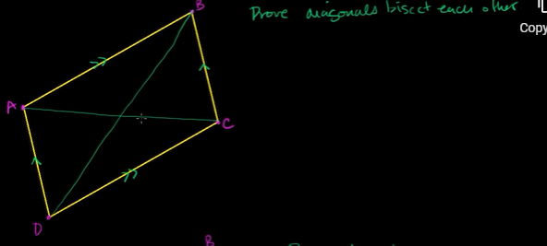
Diagonals just bisect each other, since opposite sides are not equal.

Opposite angle of a parallelogram
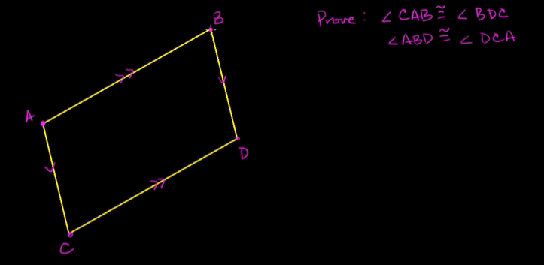
Diagonals of kite are perpendicular
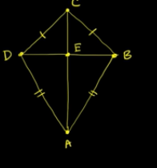

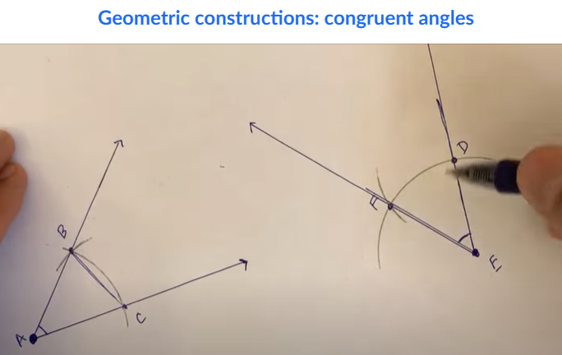
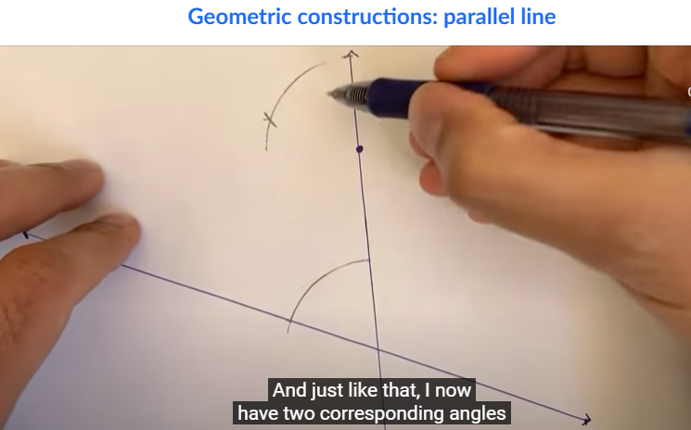
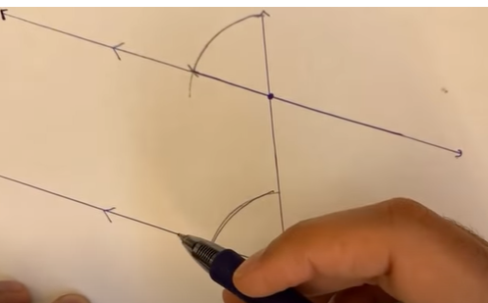

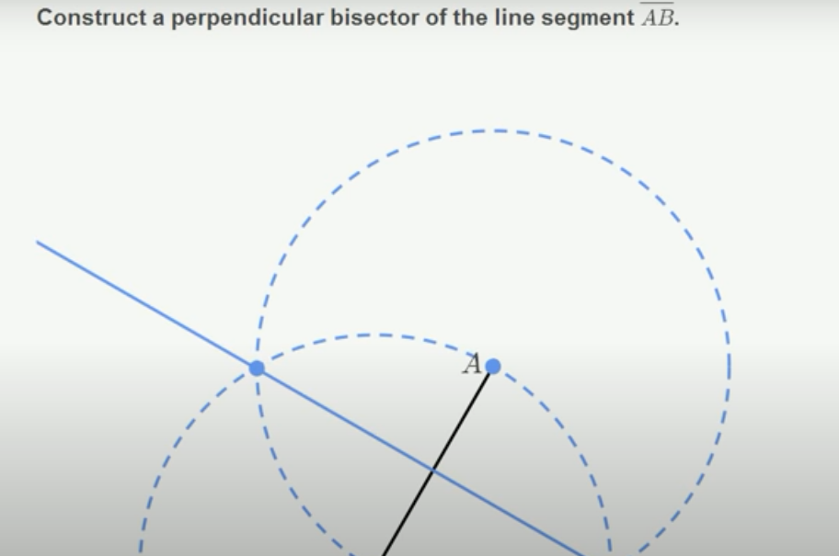

Where these two circle intersect is equidistant from both A and B
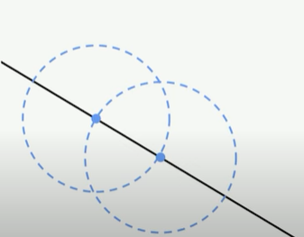

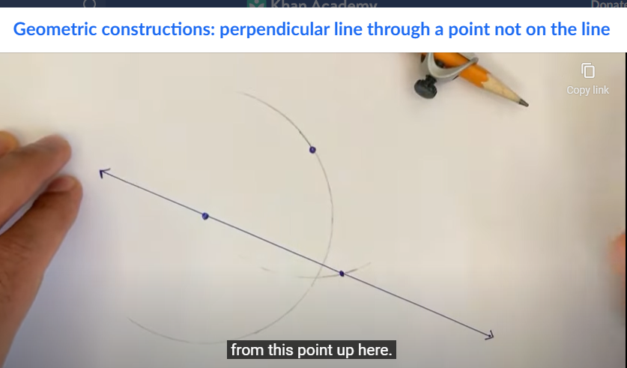

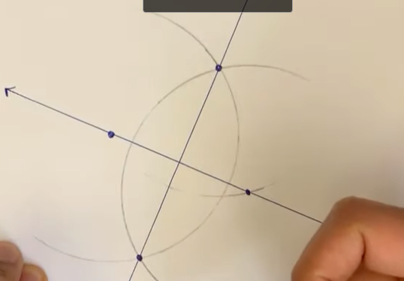
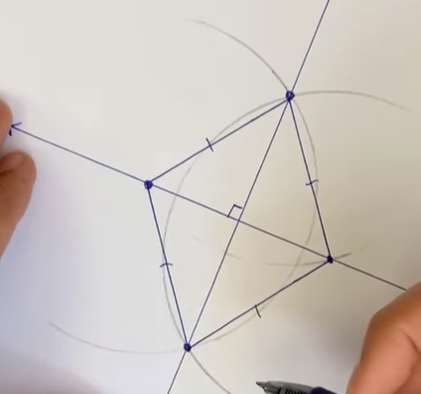

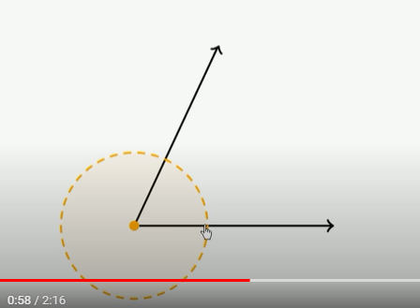
Angular bisector
We want to construct a line that is equidistant.

